SPN 1120 Elementary Spanish I
CRN 31485
Spring 2024
West Campus
Instructor: | Professor Caroline Salvador
Telephone: | Department Office
Time:
Location | online
Office Hours: | /Zoom
E-mail: | csalvador@valenciacollege.edu

REQUIRED TEXT:
Portales 2.0 LOOSE-LEAF + Code (vText) (12 Months)
978-1-54337-437-7

Portales 2.0 Code (vText) (12 Months)
978-1-54336-829-1

TEXTBOOK
There are two ways to purchase your textbook:
- Go to Valencia College bookstore.
- Go to publisher website
Create username and password
Click Spanish
Choose SPN 1120/1121 Multi-semester Code (for those taking both semester of Spanish)

Can’t purchase the book right away?
It is imperative that you purchase the textbook ASAP so that you can get started. If you can’t, go to www.vhlcentral.com (textbook website), create username/password, and enroll in course. Instructions here. (this is the head department demonstration please use my name)I will see your name and will give you temporary two-week access so that you do not fall behind.

COMPUTER/ TECHNOLOGY REQUIREMENTS:
Students will all need dependable access to a computer with reliable internet connectivity and a webcam that can record video and audio. While many of the class activities and files can be accessed using mobile phones, it is suggested students use a laptop, desktop or tablet to interface with the course. Basic computer literacy skills are required to ensure success at completing assignments.

COURSE DESCRIPTION:
For students without two years of recent high school Spanish completed within the last three years. The class will emphasize everyday use of the language, integrating basic grammar, vocabulary, composition, and culture through a conversational approach to Spanish. This class is not open to native or heritage speakers. A minimum grade of “C” is required if being used to satisfy the General Education Foreign Language proficiency. Four credits will be earned upon successful completion of this course.
This class is not open to native or heritage speakers. Please see definition of Native and Heritage Speakers on the next page

CLASS EXPECTATIONS: ( for Face 2 Face class)
You are expected to attend class in person. Class attendance is not optional. It is a mandatory and important part of the course. Your grade will depend on your attendance.

COURSE OBJECTIVES:
The objective is for students to achieve a novice-intermediate level of proficiency in the target language (in writing, speaking, reading, and listening) as well as awareness of the Hispanic culture. In addition to competencies, at the end of the semester you will be expected to be able to use the target language at an intermediate - novice level.

LEARNING OUTCOMES:
Student will be able to communicate verbally and orthographically in the target language at an intermediate/mid-level according to the American Council of Teaching of Foreign Languages (ACTFL) as well as develop listening and reading skills in the target language at an intermediate/mid proficiency level according to ACTFL. Furthermore, students will develop a mature attitude towards cultural differences.

STUDENT INITIATED WITHDRAWAL POLICY
- Per Valencia Policy 4-07 (Academic Progress, Course Attendance and Grades, and Withdrawals), a student who withdraws from class before the established deadline for a particular term will receive a grade of “W”.

- A student may withdraw at any time during the term in Atlas up until the withdrawal deadline June 28, 2024
- After the withdrawal deadline, students can no longer withdraw themselves

- Any student knowing that he/she is not going to pass the course stops coming to class will receive an F for the course unless he/she withdraws himself before the withdrawal date June 28th, 2024

- Withdrawing from a course is the student’s decision. The professor may recommend to drop or stay in the course however by making these statements is by no means guaranteeing a passing or failing grade.

- The professor will not withdraw a student at any time.

Click here for Valencia’s Academic Policies regarding withdrawals.

Click here for other important dates for the Summer 2024

NATIVE SPEAKERS AND HERITAGE LEARNERS
SPN 1120 (Elementary Spanish I) , SPN 1121 (Elementary Spanish II), SPN 1000 (Conversational Spanish I), SPN 1001 (Conversational Spanish II) are classes specifically designed for non-native speakers or non-heritage learners. If you are a native speaker or heritage learner, this class is not for you.
A native speaker is one who was born and raised in a Spanish-speaking country and has studied the language formerly in elementary school and/or high school in a Spanish speaking country.
A heritage learner is one who was born in the United States or moved to the United States from a Spanish-speaking country at a very young age, has never formerly studied the language, but speaks/spoke Spanish at home. A heritage learner can communicate orally with a limited vocabulary but has not fully developed writing or reading skills. In addition, proper sentence formation, correct grammatical usage, and good pronunciation are usually lacking in their conversation.
In short, “a student who is raised in a home where a non-English language is spoken, who speaks or merely understand the heritage language and who is to some degree bilingual in English and the Heritage language” (Valdes, 2000)
If you are a native speaker, this class is not for you. It is strongly encouraged that you take another language class such as Portuguese, French, German or Latin. Another option is to take the CLEP (College Level Examination Program) Test which awards college credit for demonstrating achievement in a subject by means of a computer-based exam.
If you are a Heritage learner, Valencia has created a course for you that will count as Foreign Language credit. This course is called Spanish for Heritage Speakers I and II (SPN 1340 and SPN 1341). These classes are designed for students who have some level of fluency but wish to become more fluent, become better readers in Spanish and become better at expressing themselves orally and in written form in Spanish all while improving their vocabulary and grammar. SPN 1340 is offered in Fall 2019. To both Native Speakers and Heritage Learners: You are strongly encouraged to drop this course. If you do not and it is discovered later on that you are indeed a Heritage Learner, it will leave you little or no time to register for another course or take the CLEP. https://valenciacollege.edu/students/assessments/clep.php
For Elementary language courses, we don’t allow students to use any elements of the language that we are not specifically learning in the class. Why is this? Because this is a good indication that somebody else is doing their work for them or they are using an online translator. If this happens, they receive a very low grade or a zero. For students that have some level of fluency (Native speakers or Heritage learners), it is inevitable that they use elements of the language that is not in our learning parameters. They as well, receive a low grade or a zero. As a result, in order to get a good grade, Native speakers and Heritage Learners feel forced to use a level of the language that is lower than their level of proficiency. As a result, no real learning is taking place. For this reason, we offer many other languages or Spanish for Heritage Speakers.

TWO WEBSITES
This online Spanish course will utilize TWO websites. We will be using Canvas and Supersite. The online component of our textbook is called the Supersite.

You will be using Canvas for the following:
- Keeping track of your grade
- Taking exams
- Participating in discussions
- Doing online presentations
- Seeing what assignments are due and when.
- Doing assignments not included in the Supersite
- Receiving extra materials such as worksheets, powerpoints, useful youtube and other helpful links
- Communication between professor and student

You will be using the VHL/Supersite for the following:
- Viewing tutorials
- Seeing what Supersite assignments are due and when
- Doing Supersite activities
- Doing Writing Activities

When you purchase the access code at the Valencia Bookstore, you will receive a code that will give you access to the VHL/Supersite. Click here for instructions

VHL Activities | 15%
Presentations/virtual chats/culture/flip | 15%
Chapter exams | 25%
Practice quizzes/journals(escrituras)/culture | 15%
Midterm (not for summer course) | 10%
Final Exam | 20%

Grading: Your grade will be calculated as follows:
90-100 A | 80-89 B | 70-79 C | 60-69 D | 0 -59 F
LATE WORK: Late work is not accepted. Please turn in your assignments on time. (Exception VHL: 10% deduction for every day that it is late).
Medical or other documentation required for other assignments. Case by case basis.

DESCRIPTION OF GRADING CRITERIA
Exams
1) You will take the Chapter exams in Canvas
2)The exam will consist of listening, reading comprehension, grammatical knowledge, writing and cultural competence.
3) You will have 3-5 day window to complete the exams. Once that window closes, you will not be able to make up the exam
4) The exams are timed
5) Once you begin the exam, you must complete it in one sitting
6) The chapter exams will be proctored by Honorlock. Any indication of cheating will result in an automatic zero.
7) You are expected to put accent marks when necessary. I will provide accented vowels and other special characters for you to copy/paste.
8) Included in the chapter exams are the writing assessments. Writing assessments will be based on various topics covered in the lessons. They should include grammar, sentence structure and vocabulary that we are learning or are learning in the lesson. Advanced grammar, sentence structure and vocabulary will be deemed suspicious resulting in a zero.

Speaking assess/Flipgrid disc/virtual chats/presentations
- Flipgrid Discussions: You will be asked to post short videos where you will post questions or statements in Spanish. Part of these assignments is to respond to your classmates. Make sure you read the instructions for each discussion activity. These will be done in Flipgrid which is integrated in Canvas. Feel free to use visuals.

- Presentations: Submit a presentation on the Flip app in which you discuss a topic usin the grammar and vocab of the lesson.

    - Reading is not permitted

    - Remember to use only the grammar and vocabulary that we are learning in class. By using advanced grammar and vocabulary, it will look like you are not doing your own work which will result in a very low grade or even a zero. (up to professor’s discretion)

    - Must be one continuous recording. You are not permitted to stop the recording and the restart it. Will result in a zero.

- Included in this criteria are Virtual Chats: Virtual Chats are activities included in the VHL online platform. With virtual chats, you will be asked questions by an Avatar. You are expected to answer the questions in complete sentences in Spanish. You will be able to see the questions as well. Remember, even though these activities are in VHL, they will be included in the ‘speaking’ category in the grading criteria. Virtual Chats will always be under the title “Communicate” in the assignment list in VHL.
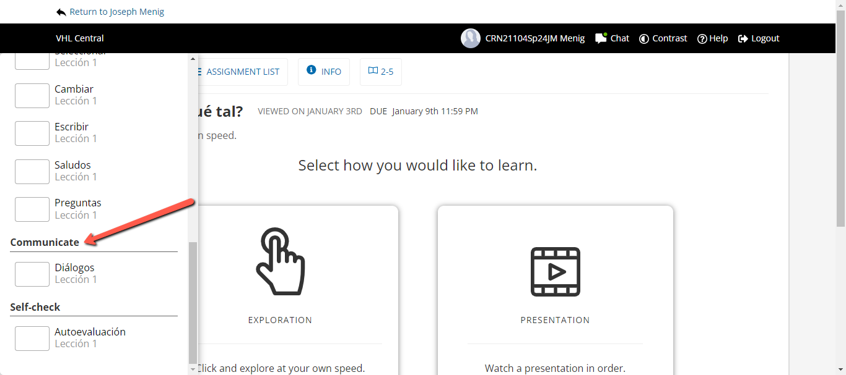

- Culture: We will discuss cultural topics related to the Spanish-speaking world. These will be done in English. You must submit an initial a well-thought out post and then respectfully respond to two other students in order to receive full credit.

Practice quizzes and journals (escrituras)

- Practice quizzes are assigned 3-4 times throughout the chapter. They are short quizzes that vary between fill in the blank and multiple choice. Their purpose is to make sure you are learning and understanding the material. You will have 3 attempts and there is no time limit.

- Journals(escrituras) are done in the VHL's Supersite. These are essentially practice writing assignments in which you will write on various topics. You are expected to use the material, grammar, vocabulary and sentence structure that we are learning in the class. Any work that uses language that is beyond our scope of learning will receive a zero. Journals will always be found in VHL under “Escritura” in the assignment list.
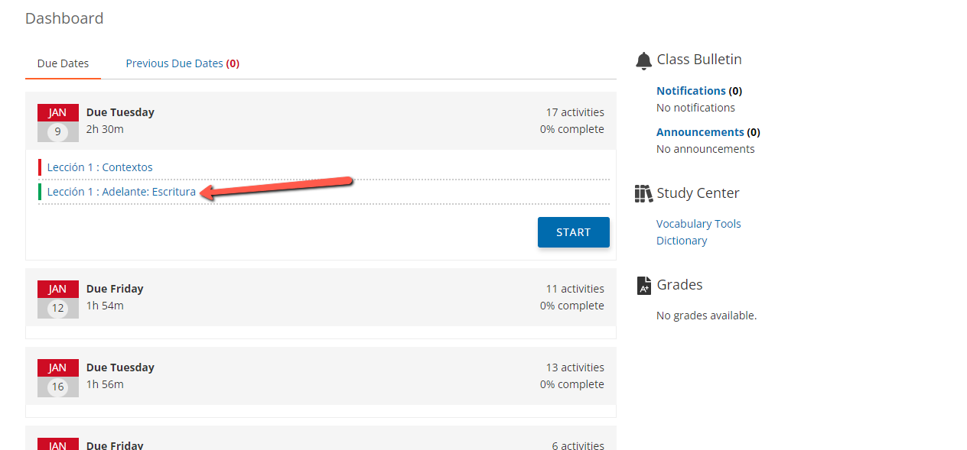

Homework in Supersite/VHL
VHL assignments can be found at VHLCentral.com. This is the online component of the textbook where you will do many of the activities of the course and keep track of your grade. VHL assignments that are not ‘journals’ or ‘virtual chats’ will fall under this criteria. The assigned activities will be listed in the calendar of the website. The activities will include extensive grammar-driven practice, vocabulary practice, listening practice, oral communication activities, reading activities, as well as activities to develop your oral and writing proficiency (journals). These activities will assist the student in internalizing the material they have learned. Homework will be completed on the dates that appear in the calendar in VHLCentral.com. There will be homework due two days/week. This is to ensure that you are staying in touch with the course on a daily basis.

For instruction on how to register on VHL, click here. Some things to remember in regards to the Supersite/VHL

- The professor will not remind you every day to do your homework.
You may submit assignments late. This will result in a 10% deduction per every day that it is late

- Please be responsible and manage your time wisely. Make sure you have a working computer. Remember, there are computer lab on all Valencia campuses that are available to students

- Please read the instructions to all activities!

The final exam will cover chapters 1-5 and is composed of 2 parts
- The 3 parts are: main part (vocab, listening, reading, grammar), writing,
- Students who do not take all 3 components of the final exam will not pass
- The main part AND the “Writing” portion of the final exam will be taken in
Canvas

  - The final speaking assessment will be done with the professor via the professor zoom link between. The professor will ask you questions based on what we have learned in the class. You will sign up on sign up genius.

You cannot pass the class unless you take all 2 components of the final exam.

ACADEMIC HONESTY:

Student Conduct and Academic Honesty: Each student is required to follow Valencia policy regarding academic honesty. All work submitted by students is expected to be the result of the student’s individual thoughts, research, and self-expression unless the assignment specifically states “group project.” Any act of academic dishonesty will be handled in accordance with Valencia policy as set forth in the Student Handbook and Catalog.

VCC Expected student conduct: 10-03 Student Code of Conduct
Specific Authority: 1006.60, FS.
Law Implemented: 1006.60, FS.
Valencia College is dedicated to the advancement of knowledge and learning, and to the development of responsible personal and social conduct. By enrolling at Valencia, a student assumes the responsibility for knowing and abiding by the rules of appropriate behavior as articulated in the Student Code of Conduct. The primary responsibility for managing the classroom environment rests with the faculty. Faculty may direct students who engage in inappropriate behavior that results in disruption of a class to leave the class. Such students may be subject to other disciplinary action which may include a warning, withdrawal from class, probation, suspension, or expulsion from the college. Please read the Student Code of Conduct in the current Valencia Student Handbook.
Here is the link to Valencia’s Student Code of Conduct website: http://www.valenciacollege.edu/policies/policydetail2.cfm?PolicyCatID=10&PolicyID=3

---------------------------------------------------------------------------------------
Academic Dishonesty/AI
In this course, you are required to do your own work. There are many resources at your disposal that can assist you such as AI. AI is a powerful new tool that can benefit society in a great deal of ways, however representing work that you did not produce as your own, including work generated or materially modified by AI, constitutes academic dishonesty. Use of generative AI in a way that violates an instructor’s articulated policy or using it to complete coursework in a way not expressly permitted by the faculty member, will be considered a violation of the Honor Code.
I reserve the right to challenge ANY material you have submitted that I may believe is AI generated or copied from any other website or resource, the following will happen: 1. Warning and no credit given. 2. Second offense, no credit given, issued final notice of misconduct. 3. Third offense grounds for failure of course and dismissal.
Should the work that you submit is questionable, you will be asked to meet with the professor and will be given the opportunity to demonstrate that you did the work.
------------------------------------Absences/failure to turn in work----------------------------
In the event that you are absent or do not submit work, you will be asked for documentation if you wish to make up that work. Medical documentation should contain the following to be considered valid:
Name of the doctor
Phone number
Address of doctor
Dates of illness/injury
License number of doctor

Valencia College Expected student conduct: 10-03 Student Code of Conduct
Valencia Community College is dedicated to the advancement of knowledge and learning, and to the development of responsible personal and social conduct. By enrolling at Valencia, a student assumes the responsibility for knowing and abiding by the rules of appropriate behavior as articulated in the Student Code of Conduct. The primary responsibility for managing the classroom environment rests with the faculty. Faculty may direct students who engage in inappropriate behavior that results in disruption of a class to leave the class. Such students may be subject to other disciplinary action which may include a warning, withdrawal from class, probation, suspension, or expulsion from the college. Please read the Student Code of Conduct in the current Valencia Student Handbook.
Click for Student Code of Conduct
Here is the link to Valencia’s Student Rights and Responsbilities page

Students with Disabilities:
Students who qualify for academic accommodations must provide a letter from the Office for Students with Disabilities (OSD) and discuss specific needs with the professor, preferably during the first week of class. The Office for Students with Disabilities (West-SSB 102) determines accommodations based on appropriate documentation of disabilities. The goal at the OSD is to open doors, remove barriers and assist you in any way the can. The key to success is matching your needs to the services provided. Please contact this office to discuss your individual needs. Here is the link to Valencia’s OSD website
West Campus
SSB, Rm. 102 Ph: 407-582-1523 Fax: 407-582-1326 TTY: 407-582-1222

Security Statement:
We want to reassure you that our security officers are here around the clock to ensure the safety and
security of the campus community. It’s important to remain alert and aware of your surroundings,
especially during the early morning or evening hours. Remember that you can always
call security for an escort if you feel uncomfortable walking alone on campus. White security phones can
also be found in many of our buildings; simply pick up the phone and security will answer.
Finally, report any suspicious persons to West Campus Security at 407-582-1000, 407-582-1030 (after-
hours number) or by using the yellow emergency call boxes located on light poles in the parking lots and
along walkways.

Valencia I.D. Cards
Valencia ID cards are required for LRC, Testing Center, and IMC usage. They can be obtained at the Security office in the SSB.

Disclaimer Statement: This outline may be altered, at the instructor’s discretion, during the course of the term. It is the responsibility of the student to make any adjustments as announced
This schedule of activities and exams is subject to change.

Baycare Behavioral Health’s Student Assistance Program
“Valencia is committed to making sure all our students have a rewarding and successful college experience. To that purpose, Valencia students can get immediate help that may assist them with psychological issues dealing with stress, anxiety, depression, adjustment difficulties, substance abuse, time management as well as relationship problems dealing with school, home or work. Students have 24 hour unlimited access to the Baycare Behavioral Health’s confidential student assistance program phone counseling services by calling (800) 878-5470. Three free confidential face-to-face counseling sessions are also available to students.”

RESOURCES FOR STUDENTS
C.A. R. E | https://valenciacollege.edu/students/advising-counseling/
The CARES ACT | https://valenciacollege.edu/students/cares-act/index.php
Tutoring | https://valenciacollege.edu/students/learning-support/
Student Code of Conduct Policies | https://valenciacollege.edu/about/general-counsel/policy/documents/Volume8/8-03-Student-Code-of-Conduct.pdf
Students’ rights and responsibilities | https://valenciacollege.edu/students/student-rights-and-responsibilities/

Correspondence
All correspondence with the professor must be done through Canvas or through your Valencia email address. Correspondence will be answered no later than 48 business hours however every attempt will be made to answer within 24 hours. Any emails sent to the professor with ‘gmail’, ‘yahoo’ or any other external email address will not be answered.

